1. **Survey data Analysis:**

ANON.IP: Unique Identifier for Policyholder

ANON.Contract: Unique Identifier for Policy

These two are common fields in all the 3 files.

ResponseId: Unique ID for survey response contains 6855 records.

Distribution channel: email

User language: En

Q1_NPS_Group:

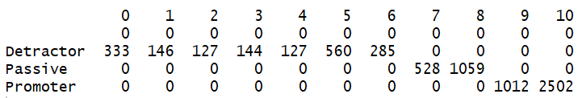

There are 6855 records (All IND), out of which 455 also have RP (Retirement plan).

*From ppt: The CX Team has launched producer surveys for all product lines to include: Retirement Plans (RP), Ameritas Investment Corporation (AIC), Ameritas Group (Group), and the Individual Division (IND).*

D-1722

pr-1587

ps- 3514

1. **Email Listing data:**

There are total of 73236 records(All IND). Out of 73236 emails sent, 2207 have RP plan along with the IND plan.

IND: Flag indicating whether the customer owns a IND policy, it has all Y.

|  |  |  |
| --- | --- | --- |
| *IND corresponds to Individual Division. The individual division offers a broad spectrum of life insurance, disability income insurance and annuity products designed to meet the needs of our customers. Offered through a nationwide network of financial professionals, our products help protect against the uncertainties of life while providing the peace of mind to enjoy life at its very best.* |  | |
| IND_COUNT_POLICY: 104216  Life.policies: 62992  Di.policies:20973  An.policies: 20917  If the IND is divided into these 3 categories, which sums up to 104,882. We have noticed a difference in tying up these numbers. There is difference of 666 policies in these individual buckets which are not accounted in the IND_COUNT_POLICY?   1. **Sales data:**   On searching for the ANON.Contract values for those email listings, in sales data:  They are all missing values in the Sales data. Out of 217224 obs in sales data, 41012 obs do not have any values except for ANON.Contract. |  | |
|  | |

May be these are the ones, categorized as blanks in the email list as well. Not sure on how to proceed with these blank observations.

Summary on the field Product.line:

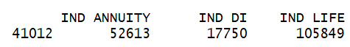

Summary on the field Product.type:

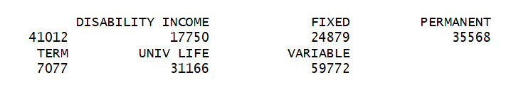

We need to know the IND policy category and rest of the sales data for these 41012 lines.

Glossary:

Policy.Client.Role.Type: This correspond to the relationship of policyholder and the policy. i.e., whether the policy holder is owner or joint owner and certain other values which are not sure about. There are 41012 blanks in this as well.

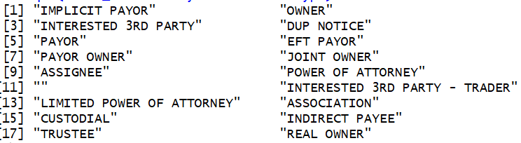

|  |
| --- |
| Need a better understanding on the fields and cash flow in the below amount columns:  Account.Value |
| Annualized.Premium |
| Coverage.Face.Amount |
| Net.Cash.Value |

|  |  |
| --- | --- |
| Bill.Frequency | Why is there no bill against some observations |
| Billing mode | what does direct bill mean; by modes does it mean - there are cash payment methods, check methods, card payment |
| Allocated.Amt | says it is the precent of policy but 1 is put against the observations; does it mean 100% that the agent was responsible for |
| Main.Agency.Distribution.Region | what does institutional, agency, Di focussed mean; does it mean the agency has these 3 categories of distribution segments; if yes what do they mean |
| Agent.Type | what does primary contract mean when it has categories-service record, PGA manager |
| Agent.Tenure.Bin | didn’t understand what to interpret of e.g. (10,15]; same for policy tenure bin |
| Insured.Underwriting.Tobacco.Code | what is tobacco status?- whether the person takes tobacco or not? And what is underwriting class- standard/preferred/composite |

Values in the column Insured.Underwriting.Tobacco.Code:

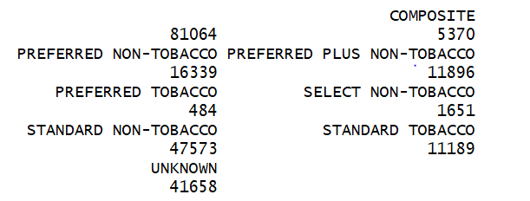

By looking at the values, RP_COUNT_POLICY and RP_COUNT_PLAN both are same.